**Project Development Phase Model Performance Test**

|  |  |
| --- | --- |
| Date | 10 November 2022 |
| Team ID | PNT2022TMID25247 |
| Project Name | AI based discourse for Banking Industry |
| Maximum Marks | 10 Marks |

**Model Performance Testing:**

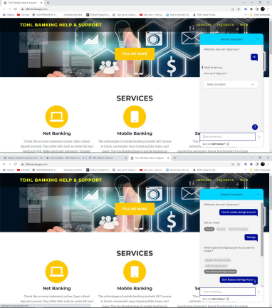Project team shall fill the following information in model performance testing template.

|  |  |  |  |
| --- | --- | --- | --- |
| **S.No.** | **Parameter** | **Values** | **Screenshot** |
| 1. | Model Summary | * IBM Watson Assistant can give for accurate responses and work for cross platform. |  |
| 2. | Accuracy | Training Accuracy - 100% Validation Accuracy -100% |  |